Chapter 1

DevOps Intro

Topics

* WHAT IS SDLC
* WATERFALL MODEL
* ADVANTAGES & DISADVANTAGES
* AGILE METHODLOGY
* ADVANTAGES & DISADVANTAGES
* DEVOPS HISTORY
* DEVOPS LIFECYCLE
* NEED OF DEVOPS
* ROLES & RESPONSIBILITIES
* BEFORE AND AFTER DEVOPS
* DEVOPS GOALS
* DEVOPS TOOLS
* ADVANTAGES

Real Life Example:

Let a ShopOnline wants to add a new feature to their website and the feature is “One-Click Payment”.

Before DevOps:

Developers worked on the feature then test it in their own machines and labs then handed it to the operations team. Suppose Problems arise during deployment causing delays and blame shifting between teams. Which make the project to be delayed and the customer satisfaction also decreased.

With DevOps:

Developers and operations team work together from start they test and deploy the feature quickly using special tools. They monitored the features performance and fixed issues fast.

Benefits:

* Faster release of the new feature
* Fewer errors and downtime
* Better teamwork and communication
* Happier Customers

**DevOps** helped shopOnline release the feature quickly and smoothly leading to increased customer satisfaction and sales. 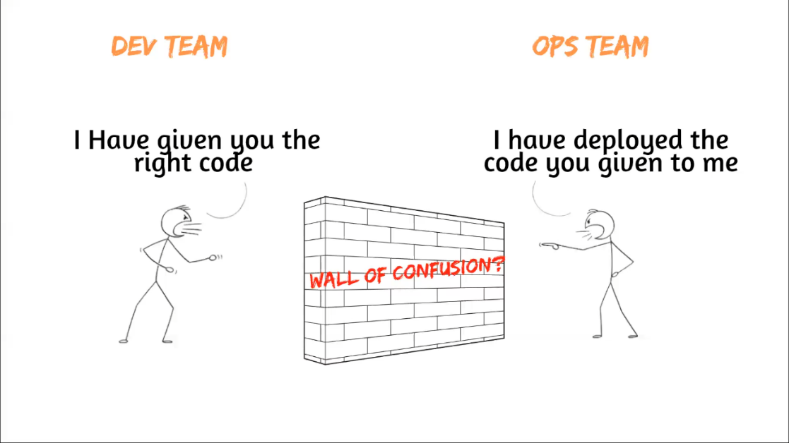

So, what if we Break the wall!

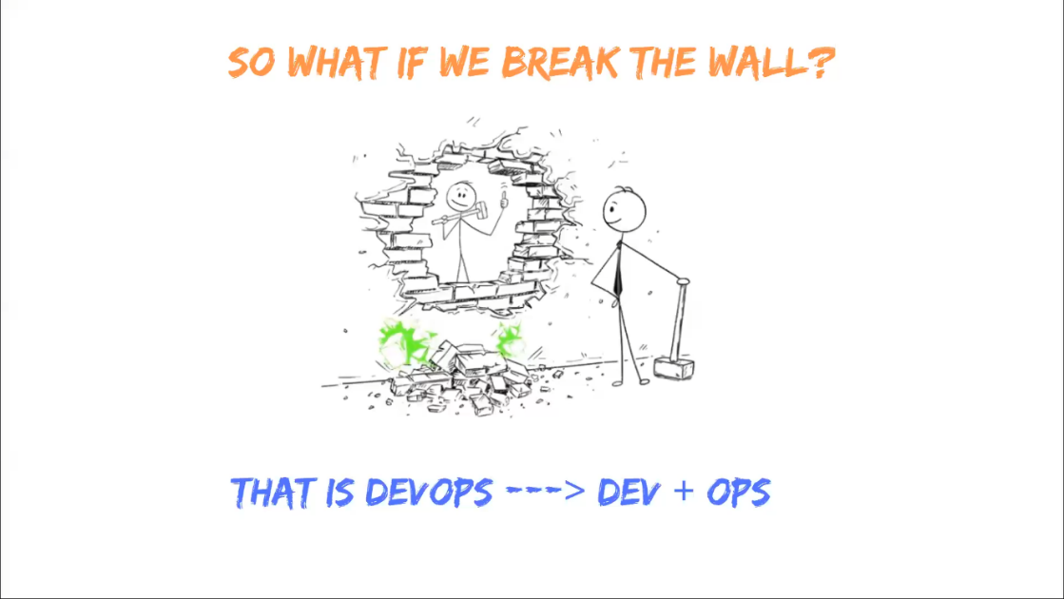

In Simple words Suppose That the development team created a software in java language and when they hand over to the operation, they installed it but the software still not work. Then the operation team will blame the development team that there are mistakes in the development but actually the mistakes was that the operation team not installed the requirements to run java programs. So, there was a misconception occur in order to avoid all this mistakes devOps came at the market.

SDLC (Software Development Life Cycle)

Is a systematic process used to develop, design, test and deliver software products .it provides a framework for managing and controlling the development process ensuring that the software is delivered on the times within budget and meets the required quality standards.

**There two groups mainly work on a Software Domain!**

i) Development Team.

ii) Operation Teram.

i) Development Team:

The Following are the responsibilities of a development team.

a) Plan:

In this Step the development team,

* define the projects goals and objectives.
* Identify the problems you want to solve.
* Determine the resources needed (Time, Money, People etc.).
* Set Timelines and Deadlines.
* Create a rough outline of the work to be done.

b) Code:

In this Step the Development Team,

* Write the Code in a programming language using the design specifications and requirements as a guide.

c) Building:

In this Step the Development Team,

* Add The Dependences such as if we need to write the code in java, we have to install java compilers.

d) Testing:

In this Step the Development Team,

* Ensures a that the product meets the required quality and functionality.

ii) Operation Team:

The following are the responsibilities of operation team.

a) Deployment:

In this Step the Operation Team,

* Automating Deployment Processes.
* Managing Release Cycles.
* Rollback Procedures.

b) Operate:

In the this Step the Operation Team,

* Track the performance.
* Tracking the availability.
* Tracking Health of application.

c) Monitor:

In this Step the Operation Team,

* Setting up Servers.
* Keep everything Updated.
* Protection against any threats.

Shortcut to Remember SDLC:

‘Pakistan Cricket Board

Director

TOM’

|  |  |  |
| --- | --- | --- |
| P | C | B |
|  | D |  |
| T | O | M |



P: Planning



C: Coding

Responsibilities of Development Team

Responsibilities of Operation Team

B: Building



T: Testing

D: Deployment

O: Operating

M: Monitor

DevOps History

* DevOps was originated in the year 2008.
* Originally it was discussion between two people called Andrew clay and Patrick debios.
* In 2009 they held a summit at Belgium then they have discussed what if DevOps comes into the market.
* In 2014 the annual state of DevOps Report was Published.
* If DevOps had a birth certificate the father’s name would be penned in as Patrick debios.

Models Used Before DevOps

1) Waterfall Model:

The waterfall methodology also known as waterfall model or classic model is a sequential development process to develop the software systematically.

* It will follow step by step execution.
* We can work on one step at a time.

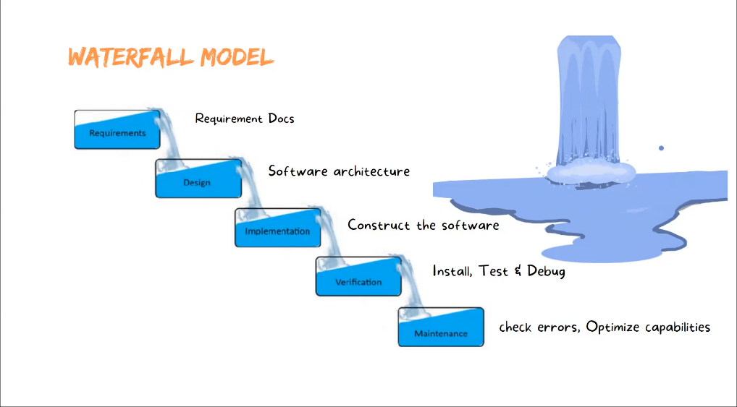

Disadvantages:

* You cannot go back to previous step.
* Not good for complex Projects.
* High amount of risk and uncertainty.
* Not suitable for the projects where the requirements are at moderate to high risk of changing.

2) Agile Methodology:

The agile methodology id a way to manage a project by breaking it up into several phases.

* Agile in word mean “Speedily”.
* In Agile Methodology we deliver small pieces of working software’s quickly to improve customer satisfaction.
* Both Development and Testing activities are done at the same time.
* In waterfall we able to work on a single step at a time. But in agile we work on two steps at a time.

Disadvantages:

* Agile’s incremental approach makes it challenging to predict costs, time, and resource requirements upfront, especially for larger and complex projects1.
* Agile emphasizes just-in-time documentation, which can result in less detailed and fragmented documentation1.
* Incremental delivery can lead to fragmented components rather than a cohesive whole.
* Agile’s minimal planning can cause projects to lack a clear vision of the final product, leading to ongoing development without a defined endpoint.
* Tracking progress across cycles can be challenging due to incremental delivery

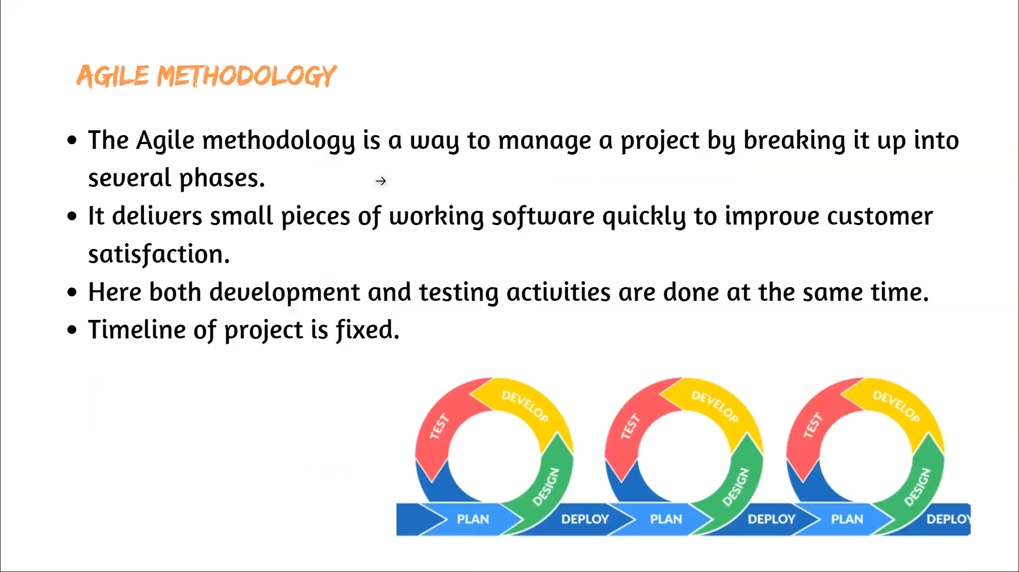

Important Points

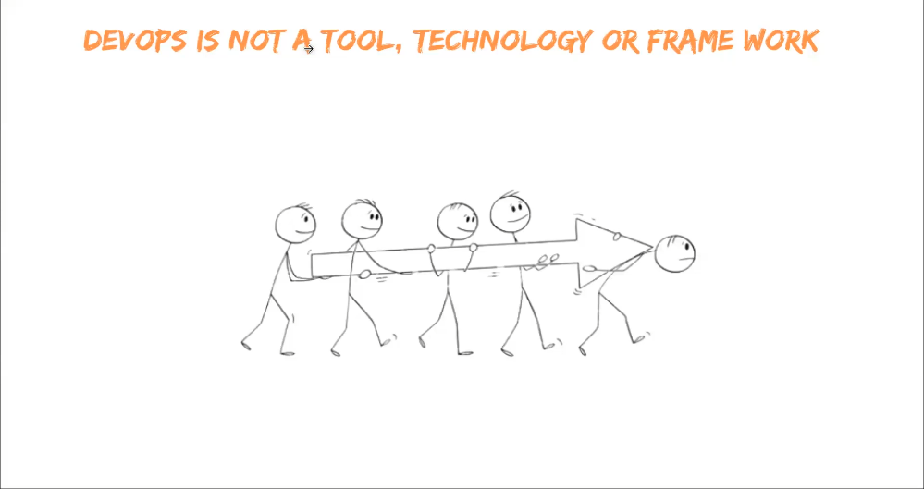

* DevOps is not a Tool, Technology or framework DevOps is a methodology.
* AI, Data science, Cloud, Block Chain etc. are technologies.
* DevOps is a methodology which used to release application speedily.

DevOps Lifecycle

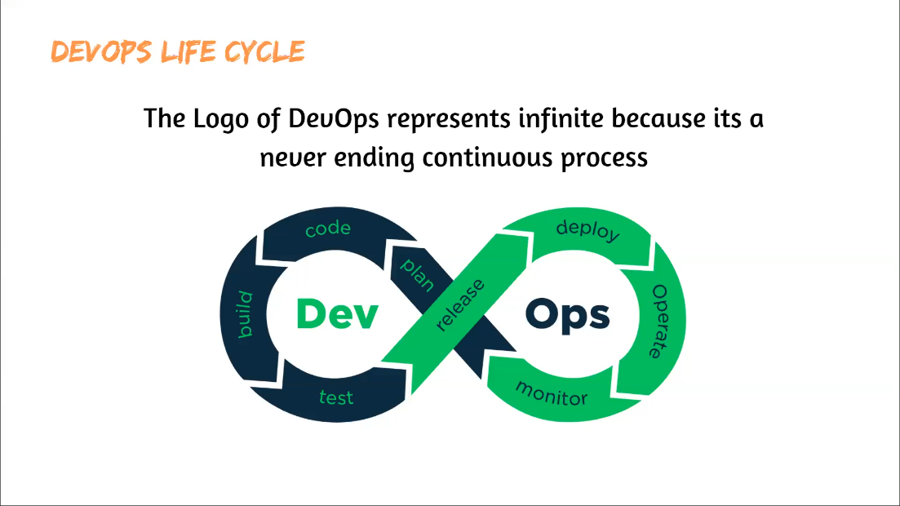

Tools used in DevOps:

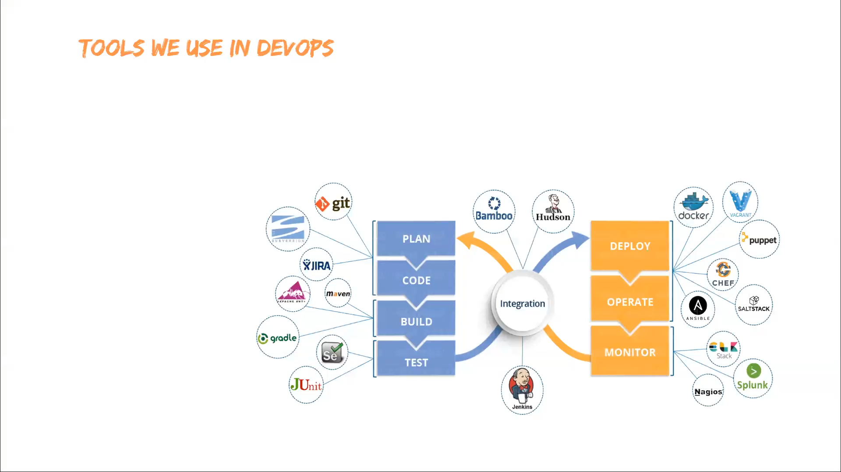

Shortcut to Remember DevOps Lifecycle:

‘Pakistan Cricket Board

DR.

TOM’

|  |  |  |
| --- | --- | --- |
| P | C | B |
|  | D | R |
| T | O | M |



P: Planning



C: Coding

Responsibilities of Development Team

Responsibilities of Operation Team

B: Building



T: Testing

D: Deployment

O: Operating

M: Monitor

R: Release

Roles and Responsibilities of DevOps Engineer

* Cloud/Server/Network Architecture.
* Configuring & Maintaining Infrastructure.
* CI/CD Pipeline.
* Automating Daily Task.
* Continues Monitoring.
* Collaboration with all teams.
* Migrating from monolithic to microservices.